**Graphics Project**

**Pepsi Man Clone**

**Team Members**

|  |  |  |
| --- | --- | --- |
| **Num** | **Full Name in ARABIC** | Code |
| 1 | عبدالعزيز صلاح محمد عبده | 9202810 |
| 2 | احمد سيد سيد مدبولي | 9202111 |
| 3 | عبدالرحمن محمد حمزه عثمان | 9202793 |
| 4 | احمد صبري عبدالراضي احمد | 9202119 |

**Presented to:**

**DR/ Ahmed Kaseb**

**Eng/ Yehia Etman**

**Date: 22/5/2023**

**Table of contents:**

**1.** **Phase 1: 3**

*1.1 Abdelaziz Salah 3*

*1.2 Abdelrahman Hamza* 3

*1.3 Ahmed Madbouly* 3

*1.4 Ahmed Sabry* 4

**2. Phase 2:** 4

*2**.1 Abdelaziz Salah* 4

*2**.2 Abdelrahman Hamza* 4

*2**.3 Ahmed Madbouly* 4

*2**.4 Ahmed Sabry* *4*

**List of Figures**

Game Start5

Game Menu5

Easy level6

Medium level6

Hard level 7

Sliding7

Colliding with object 8

Winning screen 8

**Contribution of each member:**

1. **Phase 1**
   1. **Abdelaziz Salah: REQ2, REQ3, REQ11**
      1. Participated in Implementing the mesh class which contains the Vertex Buffer, Element Buffer, and Vertex array which represents a collection of vertices and faces.
      2. Implemented the Transform Matrix which is responsible to rotate, translate or scale the objects in the scene.
      3. Implemented the postprocessing effects to apply different effects on the scene when some events occur.
   2. **Abdelrahman Hamza: REQ1, REQ5, REQ10** 
      1. Participated in implementing the shader programs which are
         1. triangle vertex shader
         2. color mixer fragment shader
         3. checkerboard fragment shader
      2. Implemented the Textures Todo and how we can load them from an image file
      3. Modified the forward renderer system class to draw the sky sphere around the camera.
   3. **Ahmed Madbouly: REQ2, REQ7, REQ9**
      1. Participated in Implementing the mesh class which contains the Vertex Buffer, Element Buffer, and Vertex array which represents a collection of vertices and faces.
      2. Implemented the Materials which define
         1. which shader will be used.
         2. which pipeline state will be set before drawing the object?
         3. what uniform values will be sent to the shader before drawing the objects?
         4. is this material transparent or not?
      3. Defined the forward renderer system which isolates the code into separate systems.
   4. **Ahmed Sabry: REQ1, REQ4, REQ6, REQ8.** 
      1. Participated in implementing the shader programs which are
         1. triangle vertex shader
         2. color mixer fragment shader
         3. checkerboard fragment shader
      2. Built the pipeline state, which we will use to store the depth testing, face culling, and blending of the colors.
      3. Implemented the Sampler which chooses between nearest and linear filtering techniques when dealing with the textures.
      4. Built the ECS framework which consists of 3 parts:
         1. Entities
         2. Components
         3. Systems
2. **Phase 2:**
   1. **Abdelaziz Salah:**
      1. Participated in implementing 3 different types of light.
      2. Implemented 4 different fragment shaders for applying post-processing effects which are:
         1. DevilTownEffect.frag
         2. Grain Noise scene which looks like adding salt and paper noise.
         3. lensDistortionEffect.frag
         4. sandWethereEffect.frag
         5. motionBlur.frag
      3. Added sound effects on certain events.
   2. **Abdelrahman Hamza:** 
      1. Added sound libraries to upload sound effects.
      2. Participated in applying game logic.
   3. **Ahmed Madbouly:**
      1. Participated in implementing 3 different types of light.
   4. **Ahmed Sabry:** 
      1. Participated in applying game logic.
3. **Screenshots:** 
   1. Game Start:

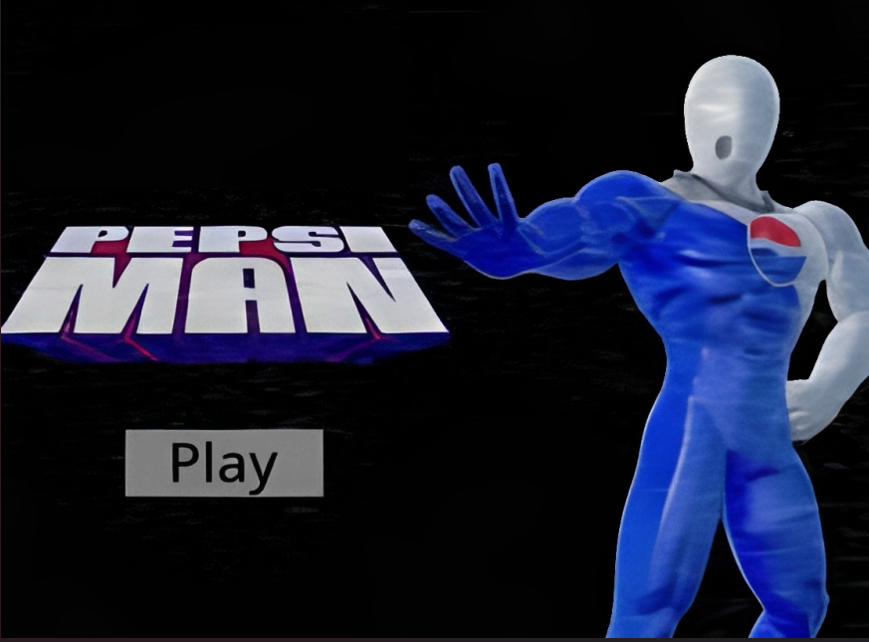

* 1. Game Menu:

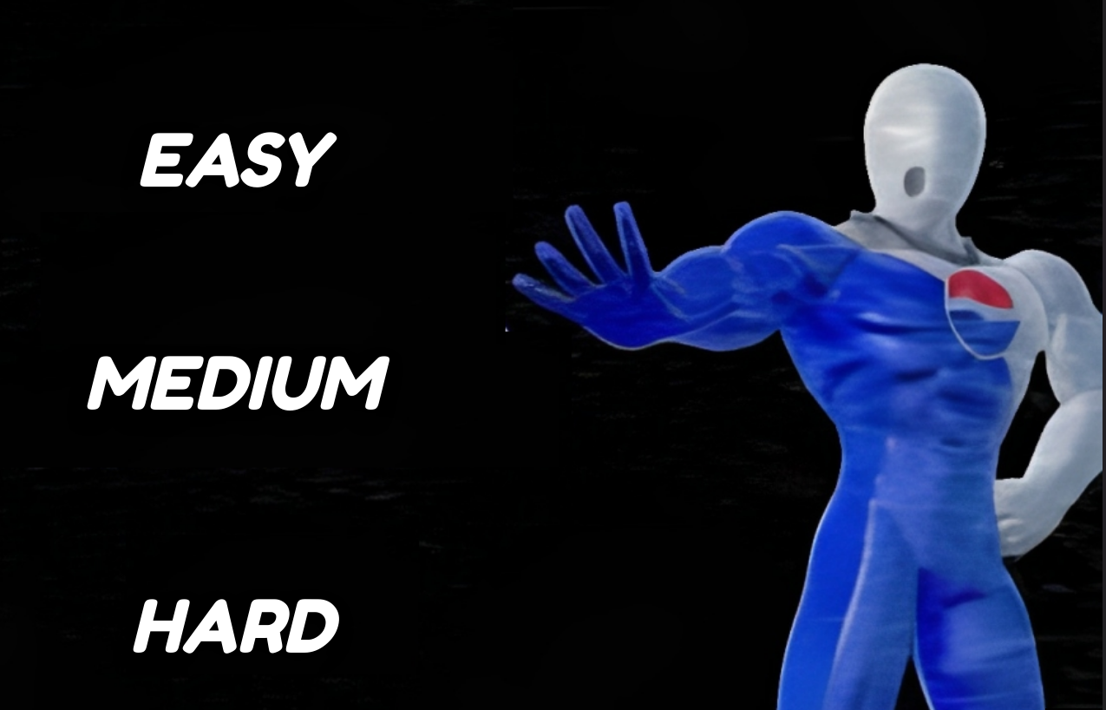

* 1. Easy level

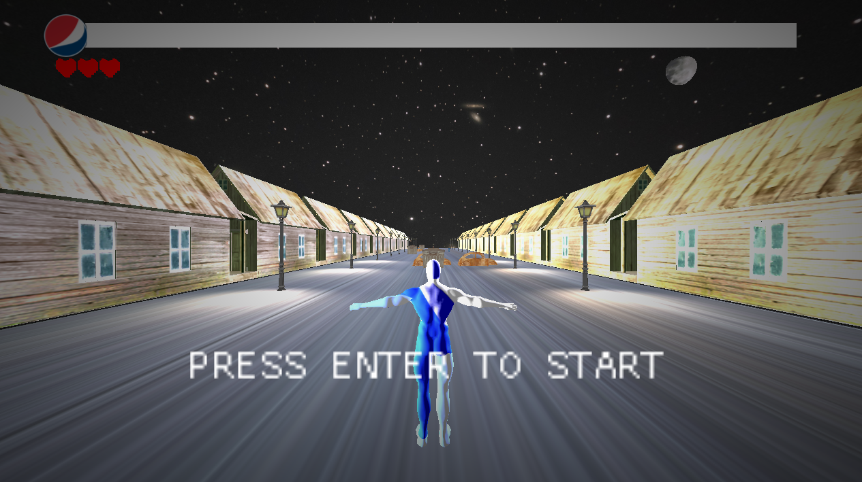

* 1. Medium level

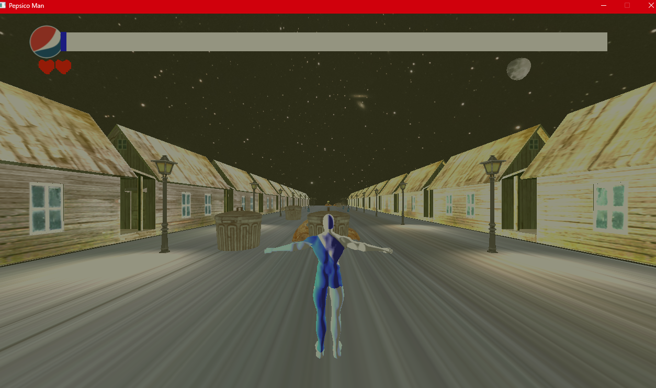

* 1. Hard level

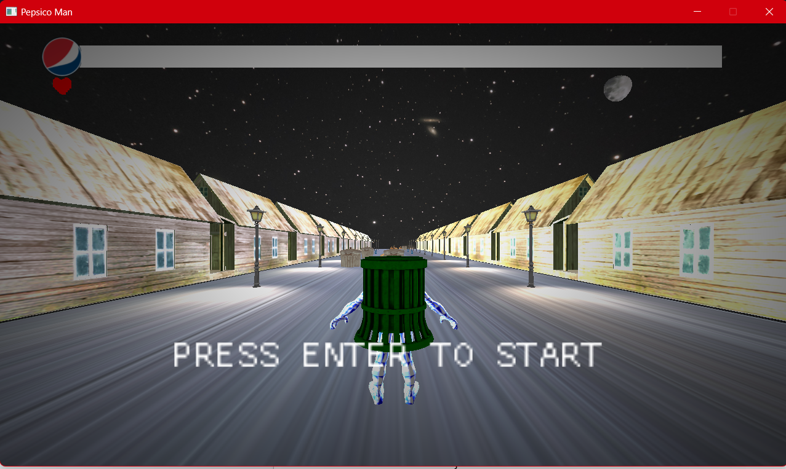

* 1. Sliding

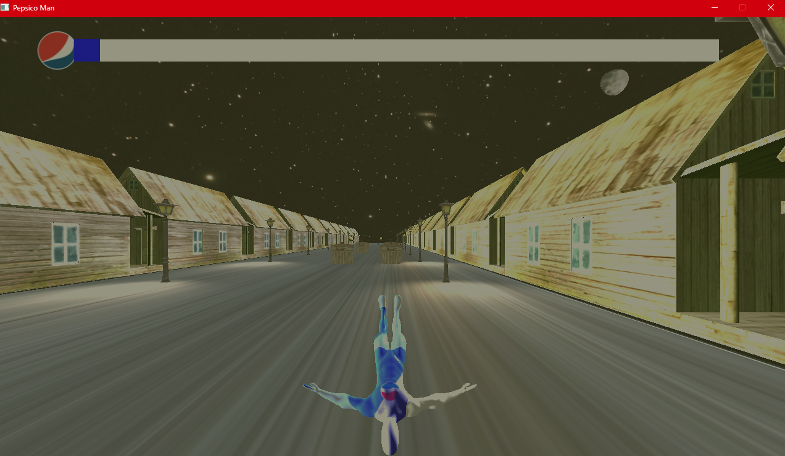

* 1. Colliding with object

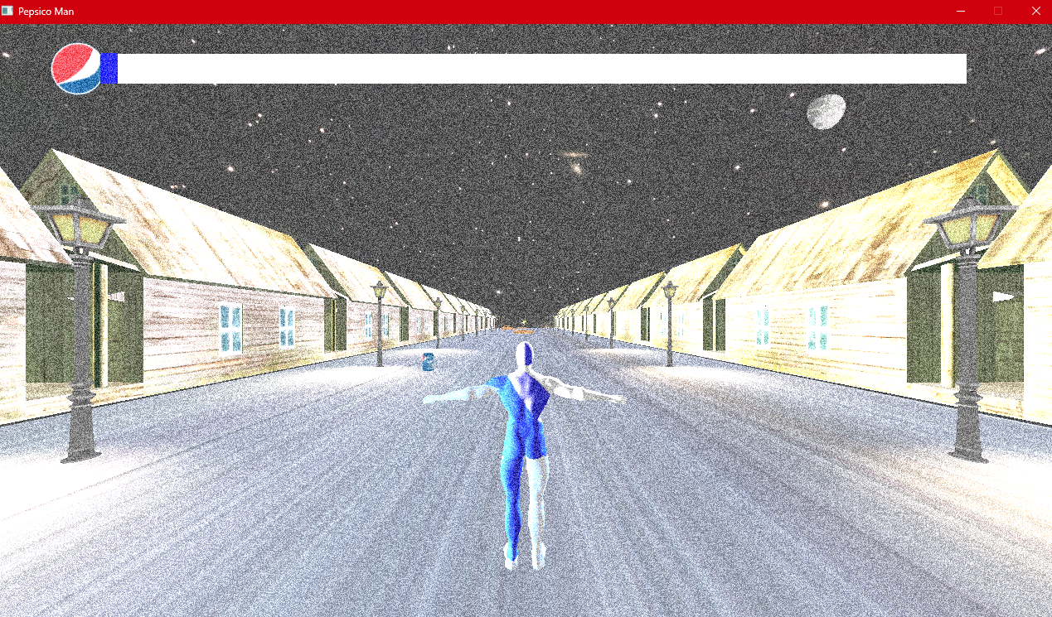

* 1. Winning screen

